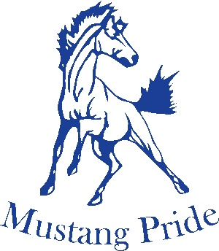
Girls “AAA” Rugby 2021-2022
Brantford Collegiate Institute & VS welcomes you to the 2021-2022 AAA CWOSSA Girls Rugby Tournament
Convenor: Jennifer Grierson-Young 519-761-2405 jennifer.grierson@granderie.ca
Dates: Wednesday May 18 and Friday May 20, 2022.
Location: Bisons Alumni / North Park Sports Complex
280 North Park Street, Brantford On, N3R2W9

 | POOL A |  |  | POOL B
1 | Brantford CI (D5) |  | 4 | KCI (6/11-1)
2 | Guelph CI (D10-1) |  | 5 | JF Ross (D10-2)
3 | Bluevale CI(D6/11-2) |  | 6 | Owen Sound (D1/7)

Wednesday May 18, 2022
Pool Play
Time | Field 1
9:00am | 5 vs 4
10:00am | 1 vs 3
12:00am | 6 vs 5
1:00pm | 2 vs 1
3:00pm | 4 vs 6
4:00pm | 3 vs 2

Friday May 20, 2022
Championship
TIME | Field 1
12:00pm | Winner Pool A vs Winner Pool B

