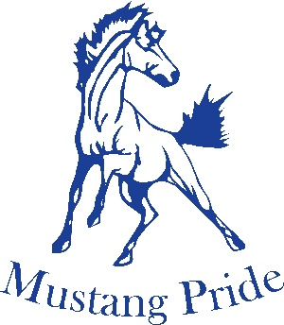
Girls “AAA” Rugby 2021-2022
Brantford Collegiate Institute & VS welcomes you to the 2021-2022 AAA CWOSSA Girls Rugby Tournament
 | POOL A |  |  | POOL B
1 | Brantford CI (D5) |  | 4 | KCI (6/11-1)
2 | Guelph CI (D10-1) |  | 5 | JF Ross (D10-2)
3 | Bluevale CI(D6/11-2) |  | 6 | Owen Sound (D1/7)

Wednesday, May 18, 2022
Pool Play
Time | Field 1 | Final Score
9:00am | KCI vs JFR | KCI (20) vs JFR (14)
10:00am | Brant CI vs Blue CI | Brant CI (22) vs Blue CI (7)
12:00am | OS vs JFR | OS (15) vs JFR (7)
1:00pm | GCI vs Brant CI | GCI (10) vs Brant CI (44)
3:00pm | KCI vs OS | KCI (5) vs OS (19)
4:00pm | Blue CI vs GCI | Blue CI (19) vs GCI (15)

POOL A Winner | POOL B Winner
Brantford CI | Owen Sound

Friday, May 20, 2022
Championship
TIME | Field 1
12:00pm | Brantford CI vs Owen Sound

